|  |  |
| --- | --- |
| **TEAM ID** | PNT2022TMID17581 |
| **PROJECT NAME** | Smart Farmer-IOT Enabled smart Farming application |

**IBM Cloud services**

**Dashboard**

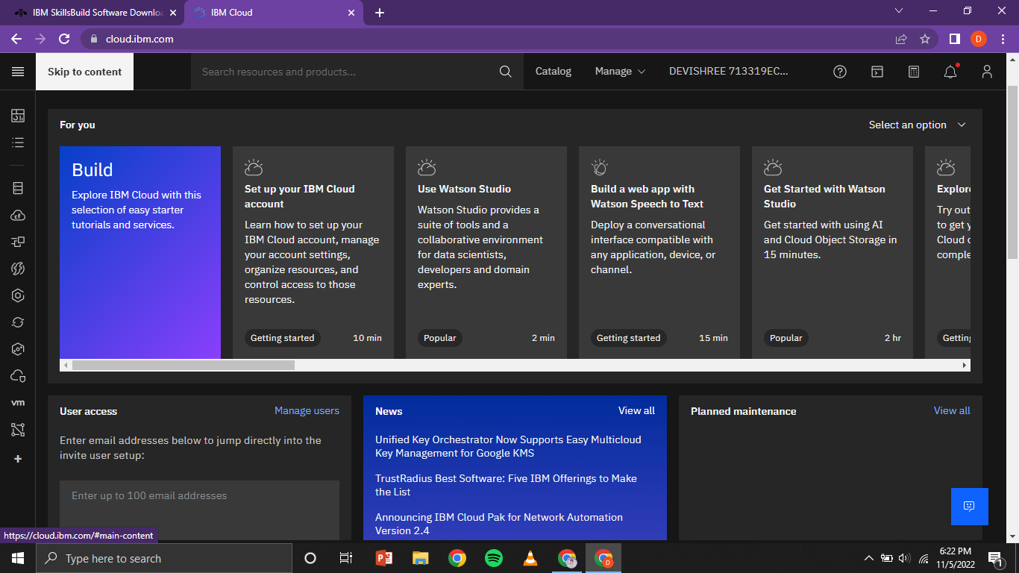

**Account Settings**

